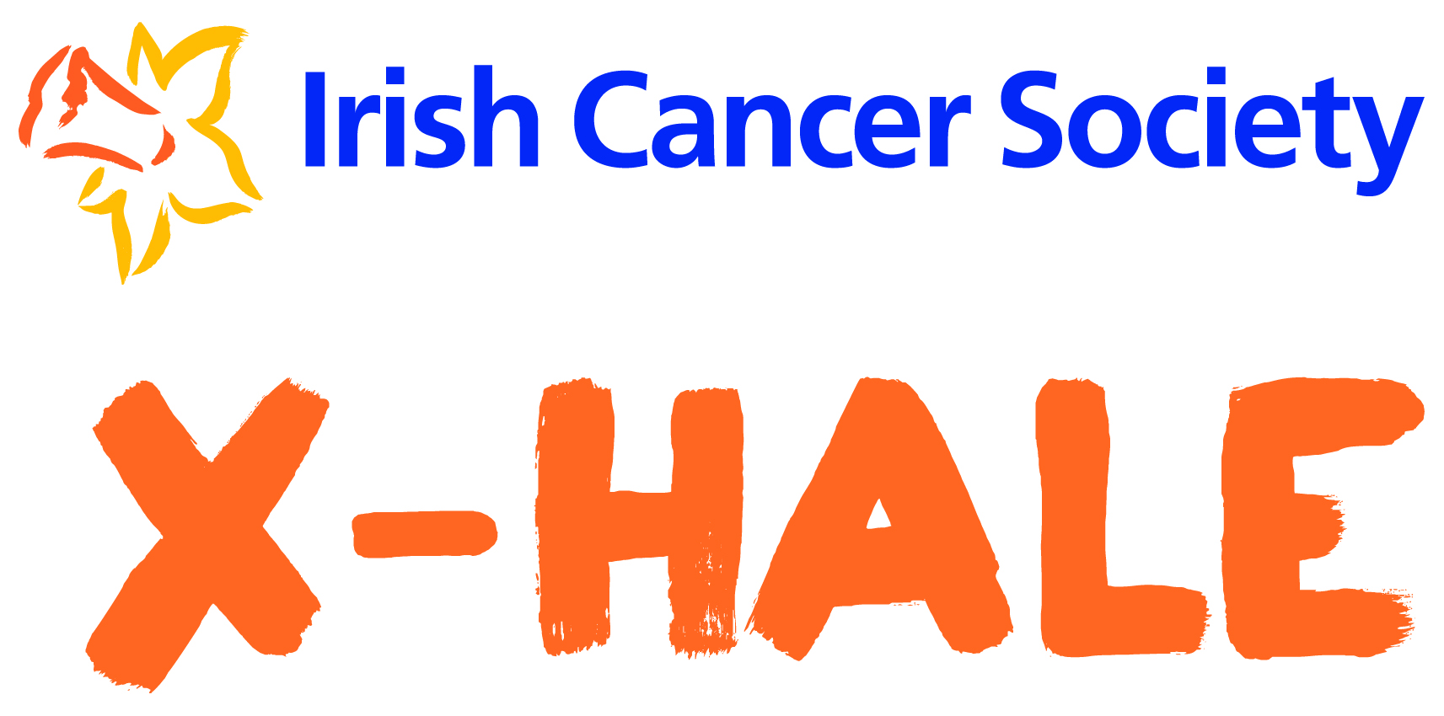
Dear Parent/Guardian,
Your son/daughters’ youth organisation has signed up to participate in X-HALE, an initiative of the Irish Cancer Society that aims to educate young people about smoking.
As part of your son/daughters involvement between March- July 2020:
- He/she may be invited to attend X-HALE workshops and events where the Irish Cancer Society, our partners and external media sources will be taking photographs/video/audio and doing surveys to capture the smoking related opinions and X-HALE experiences of participants.
- He/she will take part in X-HALE group sessions delivered by their youth worker to learn about and discuss various smoking topics including the health effects of smoking, peer pressure, the tobacco industry and the environmental impact of tobacco.
- His/her group will make a youth-led film as part of the X-HALE Short Film Competition to encourage young people to be tobacco free and to raise awareness of smoking issues. The young people involved will decide on the theme, write the script, assign roles and shoot the film with the guidance and support of their youth worker(s) and Irish Cancer Society staff. The film will be no more than 2:30 minutes in length and will feature the young people in the group that choose to act out the scripted roles and appear in the film. All films will be uploaded to the Irish Cancer Society YouTube playlist. The films will be shared on social media as part of an online competition and will be open to view by the public.
- Your son/daughter will be asked to complete an evaluation questionnaire at the end of their group’s involvement to measure changes in smoking related knowledge, attitudes and behaviours. Your child’s name will not be connected with his/her answers.
The Irish Cancer Society may use the above mentioned photographs, video, audio, films and evaluation findings on our website, social media platforms, printed publications, at events and conferences and in newspapers and media sources to promote X-HALE and highlight smoking issues/attitudes/behaviour among young people. Only your child’s name and youth organisation will be published in the photographs, video and audio taken by the Irish Cancer Society. We cannot control re-use where photographs, video, audio or films have been taken by an external organisation. Your child’s name or identity will not be shared or published in connection with evaluation survey data collected by the Irish Cancer Society.
If you understand and consent to the above in relation to your child’s involvement with X-HALE, please complete the section below and return this form to your son/daughter’s youth organisation as soon as possible.
Son/Daughter’s Name _______________________________________________________________________________
Youth organisation/group ____________________________________________________________________________
I ______________________________ (your name) have read and understand this consent letter. I give the Irish Cancer Society permission to use the X-HALE photographs, video/audio recordings taken of my child and evaluation survey data collected from my child as specified above.

Signed Parent/Guardian ________________________________________________________________________

Printed Name _____________________________________________ Date______________________

Data protection: All information in relation to X-HALE participants will be processed by the Irish Cancer Society in accordance with Irish Data Protection legislation.

