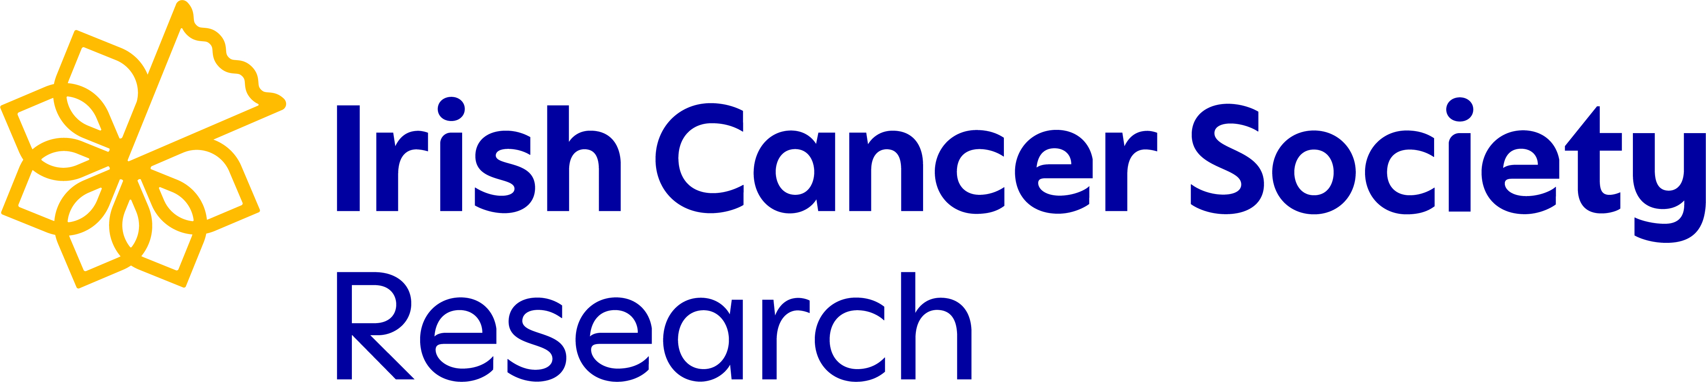

Summer Studentships 2024
Frequently Asked Questions (FAQs)
Updated: 06/12/2023

Contents
Eligibility 2
Supervisor 4
Host Institutes 5
Budget 6
Application Deadline 7
Start of Studentship 8
Other Queries 9

Eligibility

- As a first year student, am I eligible to apply?
Yes, first year full-time or part-time undergraduate students are eligible.

- I am a final year student, am I eligible for a Summer Studentship award?
No, final year students are not eligible.

- Are medical students eligible to apply?
Medical students are eligible to apply for the Translational OR Survivorship Summer Studentships. Eligibility will depend on the research project proposed, which should align with the studentship for which you are applying. If you are uncertain which scheme is most appropriate, please contact grants@irishcancer.ie by Thursday 1st February 2024.

- Are non-Irish citizens studying in Republic of Ireland eligible to apply?
Yes, if you are studying in Republic of Ireland, and you meet the eligibility criteria, you can apply for the summer studentship. It is the applicant’s responsibility to ensure they are eligible to study in Ireland.

- Are the studentships available for students to study abroad?
No, the research must take place at a host institution in the Republic of Ireland. This must be one of the HRB’s approved Republic of Ireland host institutions.

- Are studentships tenable for individuals studying in Northern Ireland?
Studentships are tenable only for researchers who will conduct their research in the Republic of Ireland.

- Is there an upper age limit to the application?
No, there is no upper age limit.

- As a pharmacy student, which studentship am I eligible for?
Eligibility will depend on the research project rather than your undergraduate degree. Your research project should align with the studentship for which you are applying. If you are uncertain which scheme is most appropriate, please contact grants@irishcancer.ie by Thursday 1st February 2024.

Supervisor
- Do I need to find a supervisor and design a project myself?
Yes, it is the applicant’s responsibility to find a suitable supervisor and design the research project in collaboration with their supervisor.

- How do I find a supervisor? Can the Irish Cancer Society help me?
We understand that students may not have had much research experience yet and may not know who is conducting cancer research in Ireland. The Irish Cancer Society cannot find a suitable supervisor for applicants. We recommend approaching principal investigators/lecturers in an area of cancer research you are interested in about the possibility of working on a project together well in advance of the application deadline.

- Can a supervisor sponsor more than one student for separate projects who are both applying for a Scholarship?
Yes, a supervisor can sponsor more than one studentship applicant.

Host Institutes
- My proposed host institute is a university that is not listed on the HRB’s list of approved institutions, can I still apply?
No. A host institution must be currently listed on the Health Research Board (HRB) list of approved Republic of Ireland host institutions.

- Can I complete my studentship at a different institution from the one I am currently studying?
Yes, the host institution does not need to be the same institution where you are completing your degree. However, it must be the institution that your proposed supervisor is based.

Budget
- How many studentships are available?
There are two Survivorship Summer Studentships and two Translational Summer Studentships available in 2024.

- Is there an overall limit for the amount of funding granted?
The total amount available is €2,500 to support the student for a maximum period of eight weeks. Proposed projects that are less than eight weeks in duration will be paid pro-rata.

- How will I receive payments?
Payment to the student throughout the project will be made through the host institution.

Application Deadline
- Does the supervisor have to approve the application by this deadline?
Yes, your proposed supervisor must approve the application by this deadline (Wednesday, 14th February 2024). They can do this through their online portal. It is the responsibility of the applicant to ensure that their application is approved by the supervisor before the deadline. Please ensure that the application is submitted with sufficient time allowed for the supervisor to approve.

Start of Studentship
- When does the successful applicant commence their programme?
The successful applicant will begin their summer studentship no earlier than 1st June 2024. The 8-week studentship must be completed before the start of the new 2024/25 academic term.

- When will applicants find out about the outcome of the summer studentship 2024?
The outcome of Summer Studentships 2024 programme will be announced in April 2024.

Other Queries
- I am unsure if my project is eligible.
If you have any concerns, please contact grants@irishcancer.ie by Thursday 1st February 2024 at the latest.

- I am unsure whether I should apply for the Survivorship Summer Studentship or the Translational Summer Studentship?
If you have any concerns, please contact grants@irishcancer.ie by Thursday 1st February 2024 at the latest.

